Amazon Warehouse Management

Name
Course
Institution Affiliation
Tutor
Due Date

Amazon Warehouse Management
Introduction
Warehouse management entails the entire oversight activities of warehouse operations. In general; the warehouse management system includes the processes of receiving. the tracking and storage of inventory. The success of handling inventory lies in warehouse management (Wich, 2021). Many firms use the warehouse management system software thus optimizing every operational and procedural process in warehouses. The implementation of a warehouse management system gives full accessibility to real-time inventory trailing, storage, staff monitoring, and demand forecasting. This paper aims to give a review of global conglomerate Amazon's warehouse management system.
Amazon Warehouse management system
Globally, Amazon is the undisputed and most successful company when it comes to e-commerce. Amazon successfully revolutionalized the way trading and trading activities are conducted. While Amazon started as a book store, it has undergone significant growth ad is presently the global e-commerce giant. In 2004, a decade after its inception, Amazon’s yearly revenues were under 7 billion dollars. Recent research estimates that by 2018, Amazon’s recorded revenue amounted to nearly 233 billion dollars (Cutter, 2019). Factually, Amazon is the fastest company in the world to reach sales revenue of 100 billion dollars. It only took Amazon 20 years to achieve this milestone. With an annual growth of 20% and a 14% stake in the global e-commerce market; Amazon is aiming to attain 1 trillion dollars in yearly sales revenue by 2027.

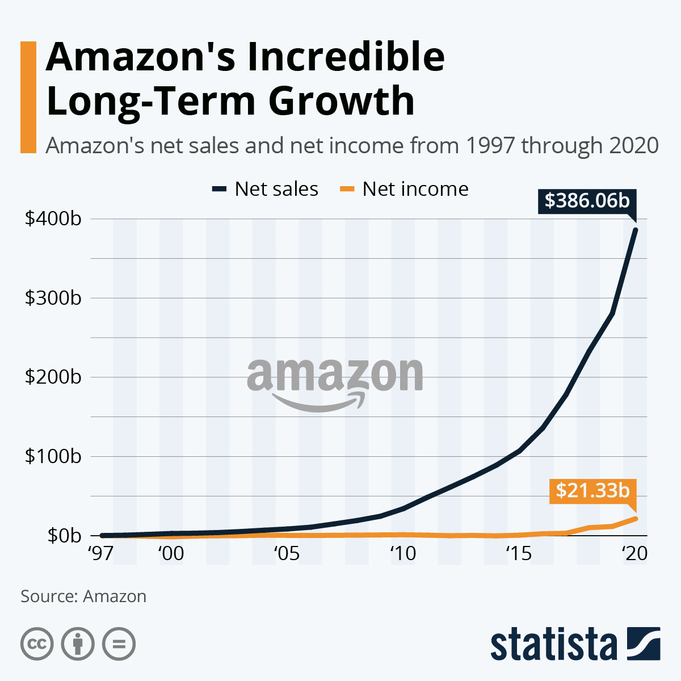
In 2006, Amazon launched the Fulfillment by Amazon (FBA) inventory handling and management system. Essentially, Fulfilment by Amazon; was Amazon’s strategy to monetize its extensive logistics network to bring onboard small companies (Schein, 2017). Globally, Amazon has an excess of 175 operation fulfillment centers with nearly 150 million square feet of space where; Amazon employees collect, package, and ship millions of Amazon customer orders daily. Amazon fulfillment centers are big facilities with thousands of employees. Amazon employees at the fulfillment centers are tasked with five basic responsibilities; unpacking and the inspection of incoming commodities, placement of goods & recording their locations, picking of goods, sorting of goods, and making the shipments (Yudiansyah, 2020). Huge supercomputers are used to record and track the location of goods while also mapping and providing routes for pickers. Amazon employees at the warehouses possess hand-held mini-computers that inter- communicate with central supercomputers thus monitoring the rate of progress when it comes to goods shipments.
Staffing is one of the most critical roles of a manager. I’m sure everyone has heard the phrase, “you’re only as good as your weakest link.” Therefore, it is essential that we hire the right type of individuals; those that are committed, motivated, and seeking development. In his very first letter to our shareholders in 1997, CEO Jeff Bezo’s wrote: We will continue to focus on hiring and retaining versatile and talented employees. We know our success will be largely affected by our ability to attract and retain a motivated employee base. Setting the bar high in our approach to hiring has been, and will continue to be, the single most important element of Amazon.com’s success. (p. 3)
Amazon has done a remarkable job creating employment opportunities for many economies. One of our best practices is recruiting students on college campuses. I plan to involve myself with our human resources and recruiting teams as they visit our local campuses, at minimum once per quarter. I personally feel that recruiting college students allows us to reach a larger pool of diverse candidates, who are eager to learn and seeking long term career opportunities. Our internship programs are an important source of talent, and some of our most senior leaders started at Amazon as interns (Amazon, 2019). As my new team becomes further developed and promoted, those college students and interns will be next in line and ready to go.
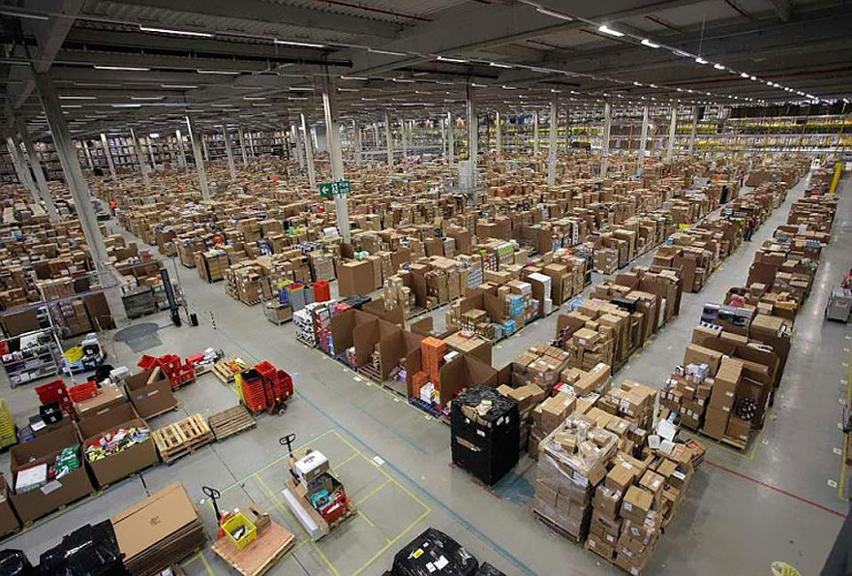Inside Amazon’s fulfillment center

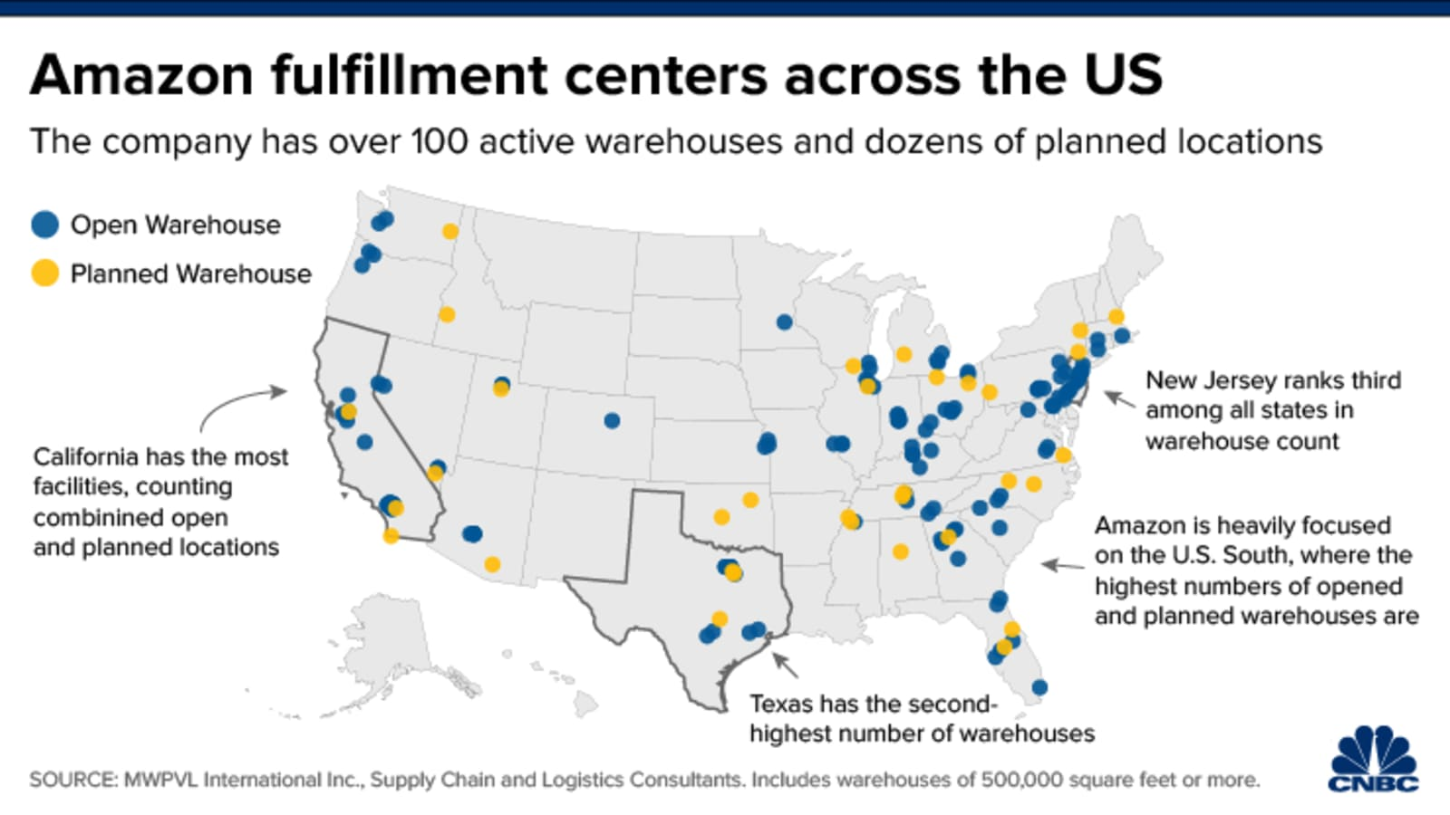

Amazon Inventory Handling
Amazon warehouses operate like typical extreme kindergarten lessons basically," Everything is in its place and there is a place for everything ''. Instead of running on spreadsheets and off-the-shelf inventory systems, Amazon uses multifaceted warehouse management systems (Schein, 2017). Sophisticated warehousing allows Amazon to smoothly handle inventory. There is no specific section for inventory instead, incoming inventory is placed where there is space by Amazon associates. Placing goods where there is space is one of the biggest reasons why Amazon delivers products quickly and efficiently.
Due to the advancement of technology, newer Amazon fulfillment centers are serviced with pods and pickers rely on Amazon robotics for easier inventory handling. Amazon warehouses have five employee teams that fast-track logistics and inventory handling. These roles are divided between stockers, pickers, packers, shippers, and problem solvers. In the event Amazon's website experienced an unfortunate website delay, Amazon would lose nearly 1 billion dollars in expected revenues (Delfanti, 2021). To stop this, Amazon strives towards streamlining both its online, and logistical operations. Amazon is continuously working towards reductions in delivery times. Many Amazon users are used to 48-hour delivery periods. In cases of easier geographical advantage, Amazon users get same-day delivery. From a business strategy point of view, Amazon has invested towards the highest possible standards of customer experiences. Consequently, Amazon warehouses are programmed to work promptly and efficiently to ensure that Amazon users enjoy fast shipping advantages. To ensure easier access, Amazon has numerous warehouses across every state thus making logistics and transportation easier (Yudiansyah, 2020).For example, if Amazon only had warehouses in Chicago, it would take time to deliver goods in Miami thus; Amazon has concentrated its warehouses across every major city for faster shipping of orders.
Amazon manages huge portions of land with nearly 80% of it dedicated towards warehouses (Wich, 2021). Unlike other retailers, Amazon doesn’t use a monolithic approach towards warehouse operations; instead, Amazon has a structured ecosystem of interconnected distribution networks.
Cross dock centers; Used to store packages from foreign vendors until the stock is needed by fulfillment centers.
Fulfillment centers: Amazon official warehouses (175 globally)
Sortation centers; Established in 2014 as a way to advance the last mile delivery. Sortation centers do not hold products but rather, Amazon robotics use zip codes to move packages in conveyor belts (Delfanti, 2021).
Delivery Stations; Amazon liaises with various distribution companies such as UPS and FedEx to ensure timely delivery of every order.
Amazon Prime; also (Now hubs); This section is used to handle perishable products likegroceries. Usually, products that need under 2 hours delivery after purchase.
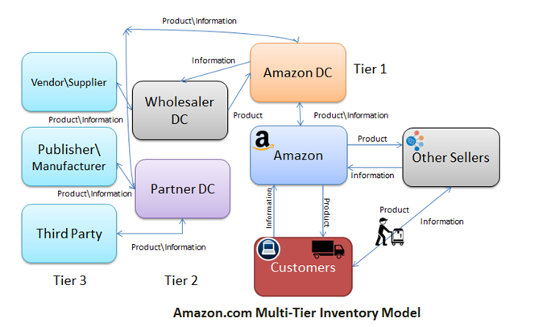
Organization of Warehousing in Amazon
The company uses divisional structure configuration while selling multiple products in various market zones. Therefore, the firm requires fulfillment centers that make up and make the organization of the warehousing activities. . Each warehouse is full of many moving parts. Following the current configuration, I will devise my warehouse into teams of pickers, packers, and shippers; and I will expect employees to learn each role. My warehouse will be departmentalized by matrix, where flexibility and adaptability in operations are possible (Baack, Reilly, & Minnick, 2014). Employees may be assigned different jobs on certain days, and will sometimes report to different supervisors. I believe that learning the roles of each department will be essential to the development of every employee.
Amazon Supply Chain
Location is everything when it comes to meeting demand and streamlining supply chain operations. Amazon's fulfillment centers are strategically located and placed. Most of these centers are closer to big metropolitans like New York, Atlanta, and Washington Dc (Wich, 2021). Due to these strategic locations, Amazon uses the Push-pull strategy for all the products stored in the warehouses thus forecasting product demand for every region. For products from 3rd party sellers, Amazon uses a more refined pure pull strategy. With nearly 110 AFCs in big cities and adjacent mini-warehouses, Amazon can constantly meet product demand.

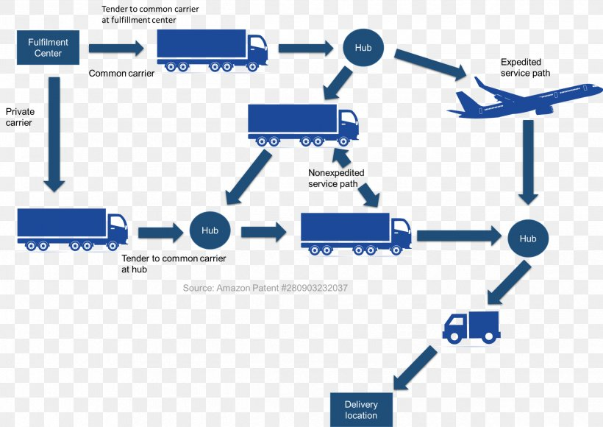
Amazon’ supply chain system

In conclusion, Amazon's efficiency in warehouse and supply chain management is a big reason behind its' success. Amazon's efficiency will give them an edge in the e-commerce trade for years to come.

References
Amazon. (2018, November 16). Training – Draft. The Amazon Blog. Retrieved from https://www.aboutamazon.com/_preview?_cms.db.previewId=00000167-2c60-da19- a9673efa9b4e0000&_date=
Baack, D., Reilly, M., & Minnick, C. (2014). The five functions of effective management (2nd ed.). Retrieved from https://content.ashford.edu/
Bezos, J. (2018). 2018 Letter to Shareholders. Retrieved from https://www.sec.gov/Archives/edgar/data/1018724/000119312518121161/d456916dex99 1.htm
Bezos, J. (1997). 1997 Letter to Shareholders. Retrieved from https://s3-us-west2.amazonaws.com/amazon.job-cms-website.paperclip.prod/shareholder_letters/2017.pdf
Cutter, C. (2019). Amazon to retrain a third of its US workforce. Wall Street Journal.
Delfanti, A. (2021). Machinic dispossession and augmented despotism: Digital work in an Amazon warehouse. New Media & Society, 23(1), 39-55
King, D. (2018). Leading vs Managing. Association or Talent Development. Retrieved from https://www.td.org/insights/leading-vs-managing
Schein, A. (2017, September). Taylorism and Amazon: Scientific management at the world's most successful retail company. In 10th Annual Conference of the EuroMed Academy of Business (pp. 1554-1564)...
Wich, S. (2021). Reflections on Amazon. Management Report for Nonunion Organizations, 44(6), 3-4.
Yudiansyah, A., Keke, Y., & Veronica, V. (2020). CAN THE MOBILE ROBOT BE A FUTURE ORDER-PICKING SOLUTION?: A CASE STUDY AT AMAZON FULFILLMENT CENTER. Advances in Transportation and Logistics Research, 3, 800-806.

